**Glossary**

1. Acme Accounting Services - third party organization that is responsible for financial procedures such as recording payments of membership fees and suspending members who's fees are overdue
2. Accounts Payable - a department of the ChocAn data center that handles payment to the providers
3. Card reader - used by the provider to read the member's identification cards in order to determine if a member is active, inactive, or suspended
4. ChocAn Data Center - a central location to obtain information about the ChocAn members, providers, and anything else related to ChocAn
5. Chocoholics Anonymous - also known as ChocAn, an organization who helps people who are addicted to chocolate
6. Electronic Funds Transfer - also known as EFT, an automated process used to transfer funds between ChocAn and a provider
7. Member - a person who obtains a service from a provider and pays a fee to ChocAn
8. Member identification card - a card given to a member that has all of the information associated with that specific member that is used by the provider at the time of service
9. Member number - a specific 9 digit number to identify a member
10. Member report - a weekly report sent to the member in an email with a list of services that have been provided to the specific member
11. Member status - a status to identify a member as either active, inactive, or suspended
12. Provider - a person who provides a service to a customer, namely a dietician, internist, or an exercise expert
13. Provider directory - a directory of six digit codes organized alphabetically that correspond to a specific service and fee that could be provided; can be requested at anytime during the week and is delivered via email
14. Provider form - a simulated form on a provider terminal that allows the provider to key in all of the information in regards to a service that has been provided to a member
15. Provider number - a specific 9 digit number to identify a provider
16. Provider report - a summary report given to a provider which includes the number of consultations and the total fee that the provider has accumulated for the week to be paid by ChocAn; sent via email
17. Provider terminal - the specific terminal that is associated with each different provider to ChocAn members; it is used to communicate with the ChocAn data center
18. Service code - the six digit number that corresponds to a specific service that was provided by a provider to a ChocAn member
19. Special report - a report that has been requested by a ChocAn manager that details the services that have been provided during that week; can be requested at anytime during the week
20. Summary report - a report that is provided to the manager of accounts payable that details every provider to be paid by ChocAn and the number of consultations each provider has made with the total fee for each provider for a given week
21. Validation - the process of determining a member's status which could return an invalid number, member suspended, or validated to the provider terminal

Chocoholics Anonymous Use Case Description

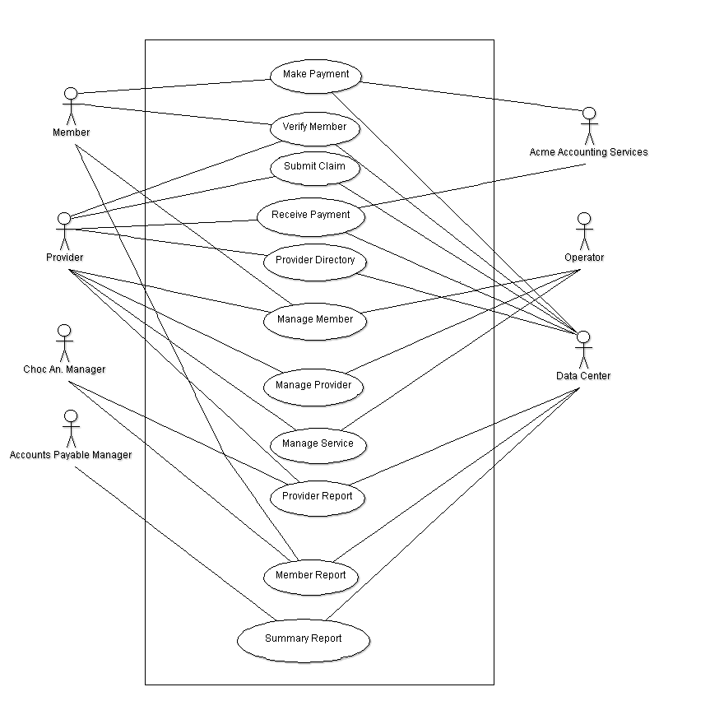

**Use Case 1: Make Payment**

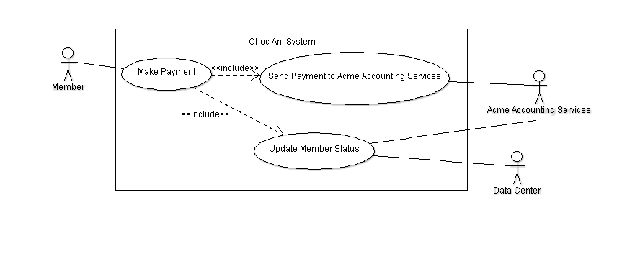

Description: The Make Payment Use Case allows the Member to make payments to Acme Accounting Services in order to remain in good standing with Chocoholics Anonymous.

Step 1: The member sends payment to Acme Accounting Services.

Step 2: Acme Accounting Services then communicates with the Chocoholics Anonymous Data Center, in order to update member’s account status.

**Use Case 2: Verify Member**

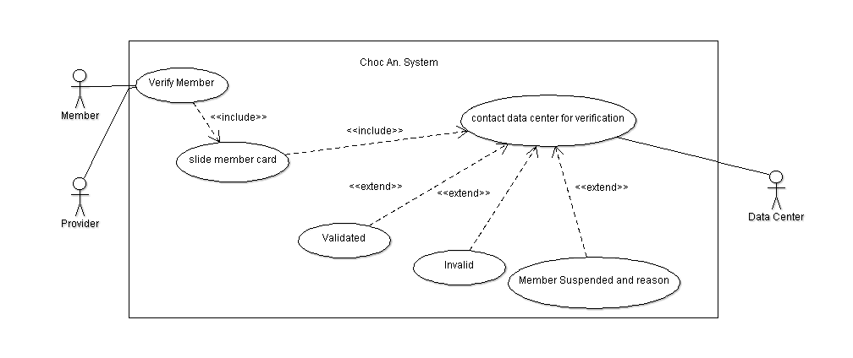

Description: The Verify Member Use Case allows the provider to verify with the data center about the member’s status with Chocoholics Anonymous.

Step 1: The member hands his/her plastic card that is encoded with the member’s name and a nine-digit member number to the provider who slides the card through the card reader on the terminal.

Step 2: The terminal then communicates with the Chocoholics Anonymous Data Center, and the Chocoholics Anonymous Data Center computer verifies the member number.

Step 3: The card reader then displays a message to the provider.

1. If the number is valid, the word Validated appears on the display.
2. If the number is invalid, the reason is displayed.
   1. Invalid Number could be displayed if the member’s number happened to be invalid.
   2. Member Suspended could be displayed and a message displayed along with it if the member hasn’t paid his/her fees for at least a month.

**Use Case 3: Submit Claim**

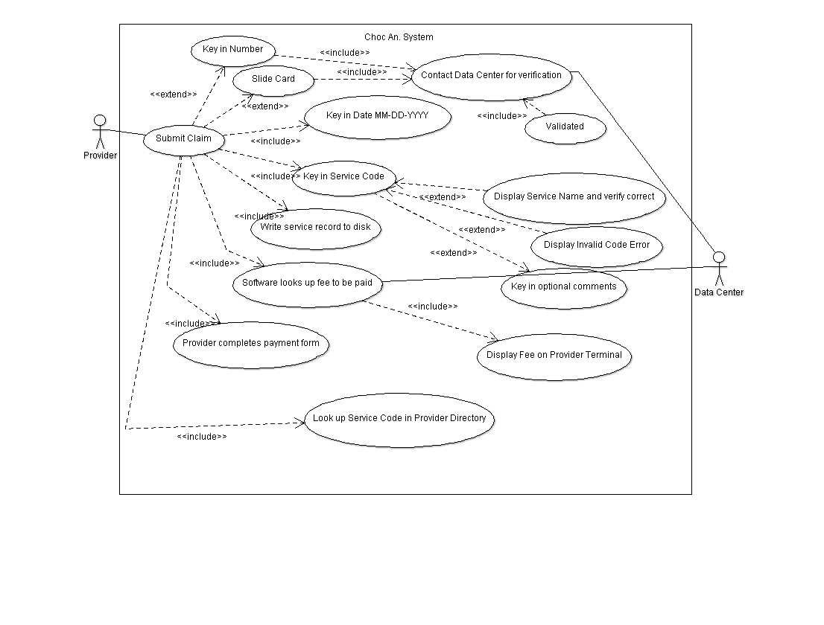

Description: The Submit Claim Use Case allows the provider to submit his/her claim to the Chocoholics Anonymous Data Center after a service has been provided to a member.

Step 1: The provider begins by swiping the member card through the card reader or he/she can also key in the member number.

Step 2: After the word Validated has appeared on the display, the provider then keys in the date the service was provided using the specific format of MM-DD-YYYY.

Step 3: The provider then uses the Provider Directory to look up the appropriate six-digit service code corresponding to the service he/she provided to the member and keys it in.

Step 4: The software product then displays the name of the service the provider keyed in, in order to ask the provider to verify what he typed in was correct for the specific service he/she provided on that date. Also the provider can enter comments about the service provided.

1. If the provider entered a nonexistent code, an error message is printed.

Step 5: The software product now writes a record of the service to disk the includes the current date and time, the date the service was provided, the provider number, the member number, the service code, and any additional comments the provider made about the service.

Step 6: The software product looks up the fee to be paid for the service that was provided and displays it on the provider’s terminal.

Step 7: The provider has a form on which to enter the current date and time, the date the service was provided, member name and number, service code, and fee to be paid.

**Use Case 4: Receive Payment**

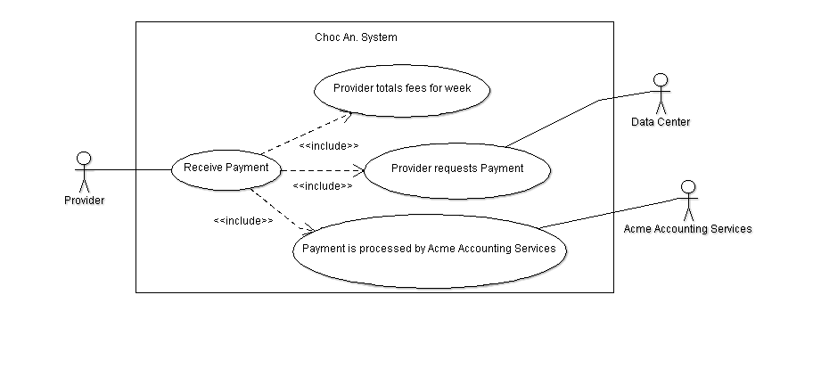

Description: The Receive Payment Use Case allows the provider to receive payment from Chocoholics Anonymous.

Step 1: The provider totals the fees to verify the amount to be paid to that provider by Chocoholics Anonymous for that specific week.

Step 2: Provider Requests Payment from Choc An.

Step 3: Payment is deposited via direct deposit to provider’s bank account by Acme Accounting Services.

**Use Case 5: Provider Directory**

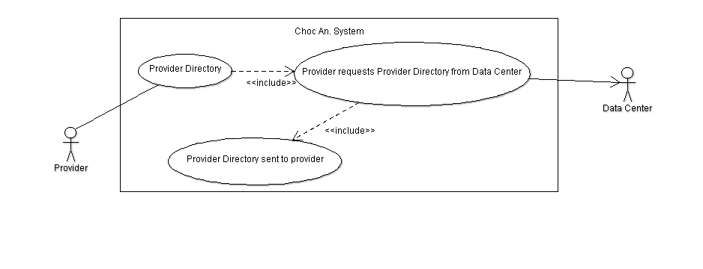

Description: The Provider Directory Use Case allows the provider to obtain a Provider Directory.

Step 1: The provider requests the software product for a Provider Directory from the Chocoholics Anonymous Data Center.

Step 2: The alphabetically ordered list of service names and corresponding service codes and fees is then sent to the provider.

**Use Case 6: Manage Member**

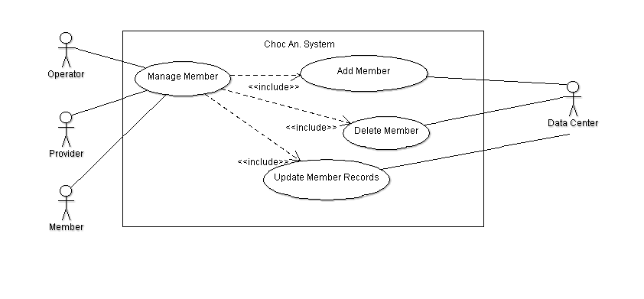

Description: The Manage Member Use Case allows the operator to simply manage new/old members to Chocoholics Anonymous.

Step 1: During the day, the software at the Chocoholics Anonymous Data Center is run in interactive mode.  
Step 2: The operator can then add a new member, delete a member who has resigned, and update member records.

**Use Case 7: Manage Provider**

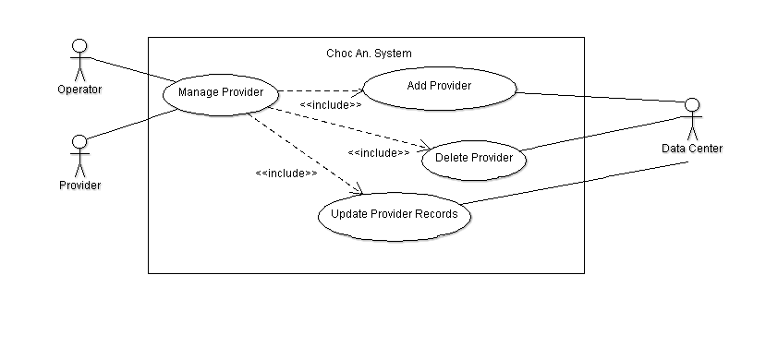

Description: The Manage Provider Use Case allows the operator to manage new/old providers to Chocoholics Anonymous.

Step 1: During the day, the software at the Chocoholics Anonymous Data Center is run in interactive mode.

Step 2: The operator can then add a new provider, delete a provider who has resigned, and update provider records.

**Use Case 8: Manage Service**

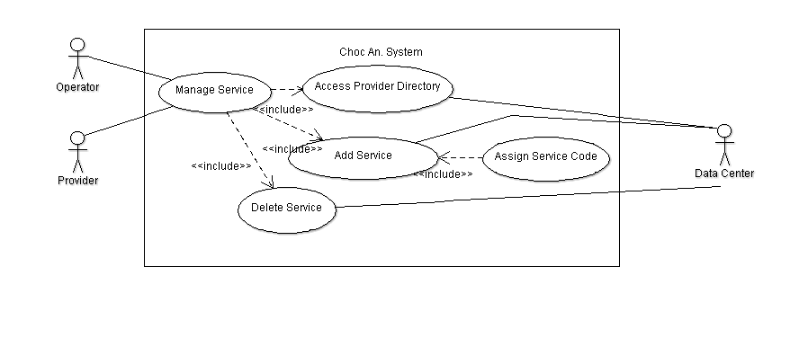

Description: The Manage Service Use Case allows the operator to change, add, and remove the services that providers can offer to the clients.

Step 1: The operator accesses the provider directory list

Step 2: The operator can then add a new service with corresponding service code and delete a service that is no longer provided by any providers associated with Chocoholics Anonymous.

**Use Case 9: Provider Report**

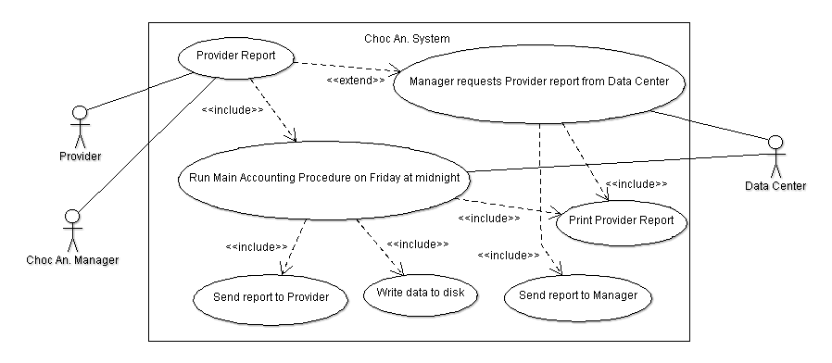

Description: The Provider Report Use Case allows the provider to receive a report from the Chocoholics Anonymous Data Center each week.

Step 1: At midnight on Friday of each week, the main accounting procedure is run at the Data Center. It reads the week’s file of services provided and prints the provider report.

Step 2: The provider receives this report, containing the list of services he/she provided to Chocoholics Anonymous members during that week.

Step 3: The report contains the same information that was entered on the provider’s form, in the order that the data was received by the computer. The report is created as a file. The file’s name begins with the provider’s name.

Step 4: At the end of the report is a summary including the number of consultations with members and the total fee for that week.

1. The fields that are provided in this report are provider name, provider number, provider street address, provider city, provider state, provider ZIP code, service, total number of consultations with members, total fee for the week.
   1. For each service provided, it also shows the date of the service, the date and time the service was received by the computer, the member name, the member number, the service code, and the fee to be paid.

Step 5: A record consisting of electronic funds transfer data is written to a disk, then banking computers will later ensure that each provider’s bank account is credited with the appropriate amount.

Step 6: A Choc An. Manager can request the report at any time.

**Use Case 10: Member Report**

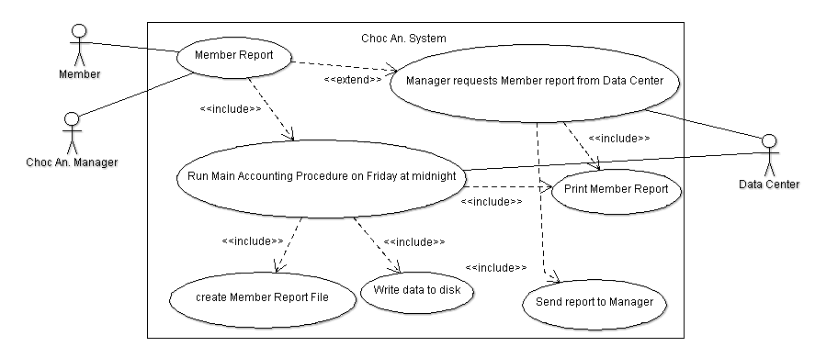

Description: The Member Report Use Case allows a member who has received a service from a provider to receive a report from the Chocoholics Anonymous Data Center for each week.

Step 1: At midnight on Friday of each week, the main accounting procedure is run at the Data Center. It reads the week’s file of services provided and prints the member report.

Step 2: The member report is created as a file whose name begins with the member name and contains the list of services he/she was provided during that week, sorted in order of service date.

1. The fields in this report are member name, member number, member street address, member city, member state, member ZIP code, service.
   1. For each service that was provided, the date of service, the provider name, and the service name are also included in the report.

Step 3: A Choc An. Manager can request the report at any time.

**Use Case 11: Summary Report**

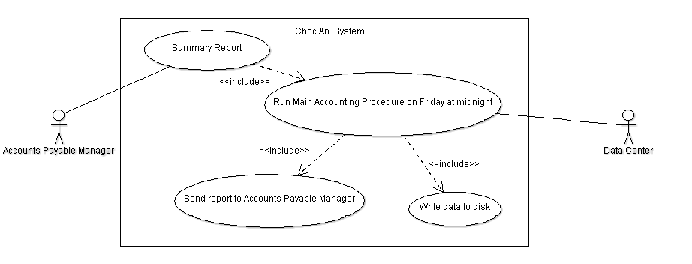

Description: The Chocoholics Anonymous Manager Report Use Case allows the accounts payable manager to have a summary report for each week.

Step 1: At midnight on Friday of each week, the main accounting procedure is run at the Data Center. It reads the week’s file of services provided and prints the Summary Report.

Step 2: The report lists every provider to be paid that week, the number of consultations each had, and his/her total fee for the week.

Step 3: The report also totals the number of providers who provided services, the total number of consultations, and the overall fee total.

Step 4: The Summary Report is sent to the manager for Accounts Payable.

**Version Control LogFile from GitHub Terminal**

jfisher4 - Tue Oct 20 15:03:02 2015 -0400, : upload the log document

Joshua Pinos - Tue Oct 20 13:39:08 2015 -0400, : Added Use Case Diagram. Removed C++ skeleton code and added java code, since GUI usage is prevalent in code.

Joshua Pinos - Mon Oct 19 23:36:17 2015 -0400, : Added skeleton files for code(Mainly for getting folder structure correct in GitHub).

Joshua Pinos - Mon Oct 19 23:33:24 2015 -0400, : Added structure for C++ code, headers files, and Makefile.

Joshua Pinos - Mon Oct 19 16:45:07 2015 -0400, : Added image of UML diagram.

Joshua Cutolo - Mon Oct 19 16:43:09 2015 -0400, : Completed Use Case Diagram using UML diagram.

Joshua Pinos - Mon Oct 19 16:23:57 2015 -0400, : Create visual UML diagram.

Joshua Cutolo - Mon Oct 19 16:19:51 2015 -0400, : Added full skeleton of all datatypes and classes, including physical components as well.

James Fisher - Mon Oct 19 15:53:01 2015 -0400, : Added all class with partial definitions

Joshua Pinos - Mon Oct 19 15:43:05 2015 -0400, : Merge branch 'master' of https://github.com/FSU-CSC-SW/R1.git

Joshua Pinos - Mon Oct 19 15:41:12 2015 -0400, : Added skeleton for UML models

jfisher4 - Mon Oct 19 15:30:58 2015 -0400, : Minor changes

Joshua Pinos - Mon Oct 19 15:28:25 2015 -0400, : Added correct uml diagrams

Joshua Pinos - Mon Oct 19 15:24:05 2015 -0400, : Removed files

jfisher4 - Mon Oct 19 15:08:53 2015 -0400, : Rename Glossary to Glossary.txt

Joshua Pinos - Mon Oct 19 15:01:19 2015 -0400, : !!!TEST!!!-Added ======= under glossary

Joshua Pinos - Mon Oct 19 14:58:51 2015 -0400, : Merge branch 'master' of https://github.com/FSU-CSC-SW/R1.git

Joshua Pinos - Mon Oct 19 14:56:05 2015 -0400, : Update Glossary

jfisher4 - Mon Oct 19 14:54:25 2015 -0400, : Update Glossary

Joshua Pinos - Mon Oct 19 14:53:47 2015 -0400, : Added files

Joshua Pinos - Mon Oct 19 14:53:29 2015 -0400, : Added file

jcutolo - Mon Oct 19 14:50:21 2015 -0400, : Create Glossary

mjinFSU - Tue Oct 6 14:27:54 2015 -0400, : Initial commit

**Time and Percentage Log**

**Task**

1. Create Glossary-

Josh Cutolo- 14 Oct 15 33%

Josh Pinos- 14 Oct 15 33%

James Fisher- 14 Oct 15 33%

2. Create Use Case Diagram-

Josh Cutolo- 19-20 Oct 15 33%

Josh Pinos- 19-20 Oct 15 33%

James Fisher- 19-20 Oct 15 33%

3. Create Version Control Log File , and Time and Percentage Log–

Josh Cutolo- 20 Oct 15 33%

Josh Pinos- 20 Oct 15 33%

James Fisher- 20 Oct 15 33%